G5r
Yearly Overview
SCIENCE

Year 1
Autumn 1  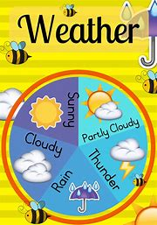 | Spring 1  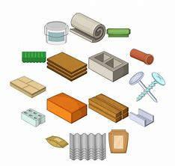 | Summer 1  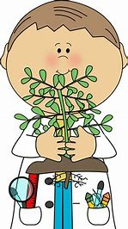
"What is the weather like today?” | “What is a material?” | “What do I know about plants?
Autumn 2  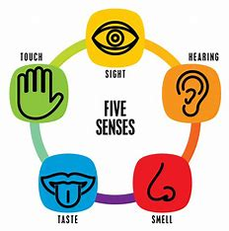 | Spring 2  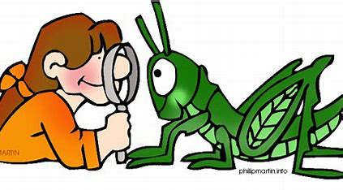 | Summer 2  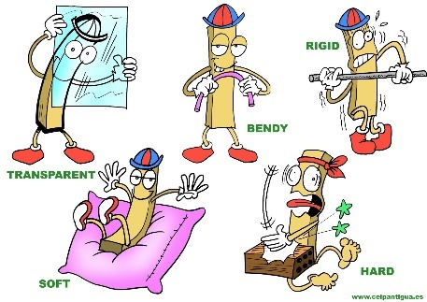
“What are my senses?” | “What do I know about animals?” | “What are the properties of a material?”
“How do the seasons change?”

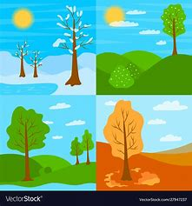
Year 2
Autumn 1  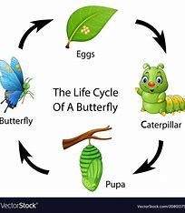 | Spring 1 | Summer 1  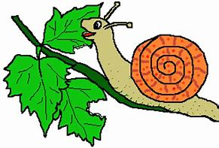
“How do animals grow and survive?” | “Why are objects made from the materials they are?” | “Where do we get our energy from?”
Autumn 2  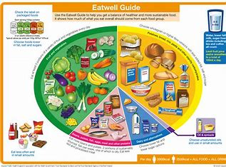 | Spring 2  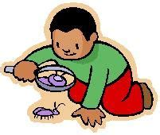 | Summer 2  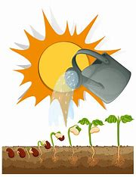
“How can I be a healthy human?” | “Why do animals live where they do?” | “What do plants need to grow?”
“How are the plants changing throughout the year?
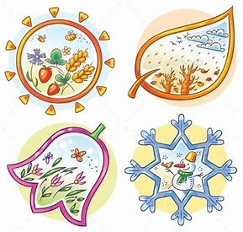
Year 3
Autumn 1  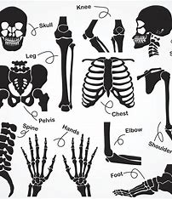 | Spring 1  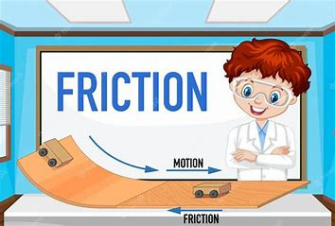 | Summer 1  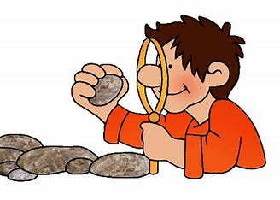
“What does a healthy body look like?” | “What is a force?” | “How can rocks be grouped?”
Autumn 2  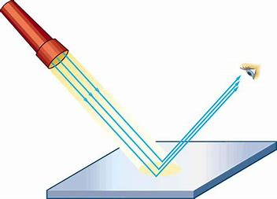 | Spring 2  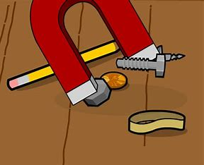 | Summer 2  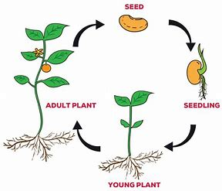
“Is light important?” | “How do magnets work?” | “What is the lifecycle of a flowering plant?”
Year 4
Autumn 1  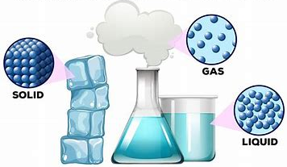 | Spring 1  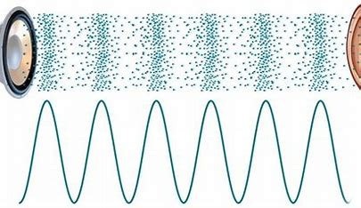 | Summer 1  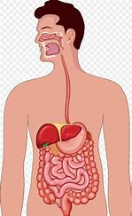
“What are the properties of solids, liquids and gases?” | “How does sound travel?” | “How does the digestive system work?”
Autumn 2  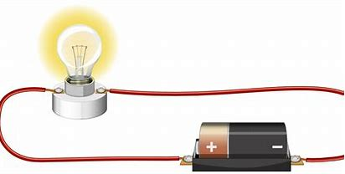 | Spring 2  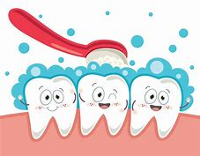 | Summer 2  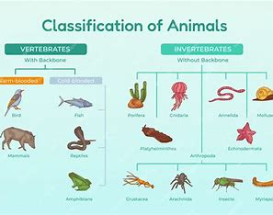
“What is electricity?” | “Why do we need to look after our teeth?” | “How can we use grouping to categorise animals?”
“How have habitats changed throughout the year?”
