YEAR 1 WRITING LONG TERM PLAN
These are the texts that will be used during the duration of the year and will act as the vehicle to stimulate imagination and creativity, as well as providing children with a meaningful purpose and audience across the units of writing outlined below.
 | AU 1 | AU 2 | SP 1 | SP 2 | SU 1 | SU 2
CLASS READER | 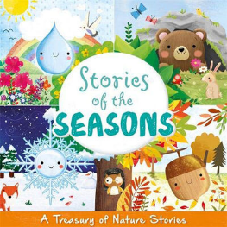 | 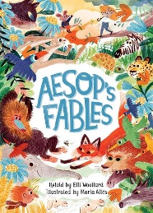 | 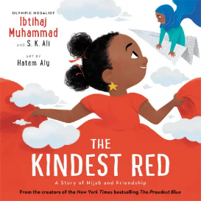 | 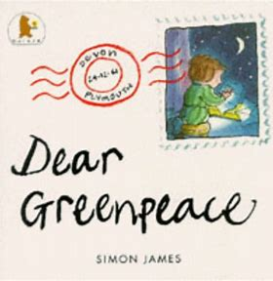 | 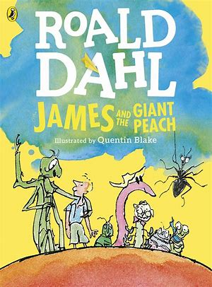 | 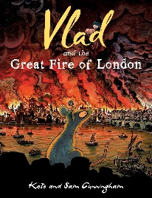
FOCUSSED TEXTS | 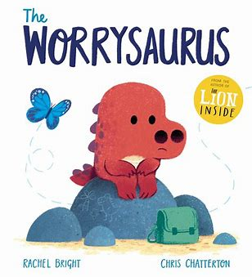 | 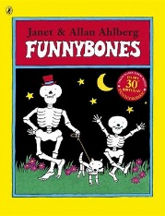 | 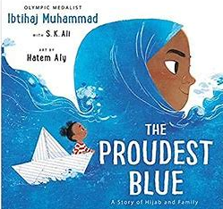 | 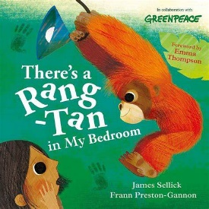 |  | 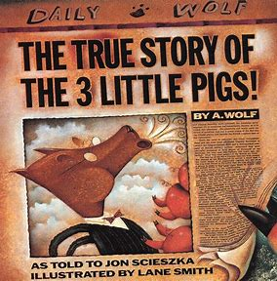
LINKED TEXTS |  | NF About the Body | F Kindest Red  P What is pink? | F Dear Greenpeace | F Fruit Poems | NF Samuel Pepys Diary
WRITING PURPOSE | To entertain  To inform | To entertain  To inform | To entertain  To inform | To entertain  To inform | To entertain  To inform | To entertain  To inform
WRITING AUDIENCE | Sending our own dinosaur stories to the author. | Writing some NF instructions about the body which will be shared in an assembly. | Creating a class book of poems. | Sending letters to Greenpeace or Prime minister about the saving the planet. | Writing a narrative to read to a child in another class. | A transition piece of writing for the next teacher.
TEXT TYPES | Story - Descriptions  Recount | Story - descriptions  Instructions | Story - retell  Poetry | Story-retell  Letter  instructions | Story/character  Letter | Story/character  Poetry  Recount/account
END POINTS | Character description of the Worrysaurus  Dinosaur story inspired by the Worrysaurus  Recount of a day in Year 1 | Narrative- Retelling of a fable/Funnybones  Narrative – funny bones story inspired using phrases from the text  Instructions on how to stay healthy | Character description  Diary entry  Story- Retelling  Poem What is xxx? | Narrative- Retelling of story  Letter-environmental issue  Instructions on how to save the orangutans. | Narrative – Characters thoughts and feelings  Writing the next chapter of James and the Giant Peach  Letter to James telling him to take or not take the magic beans and why | Diary entry inspired by Samuel Pepys and the events of the Great Fire of London  Acrostic Poem  Eyewitness account of the great fire

